**AUDIO TRANSLATION**

**https://24x7offshoring.com/**

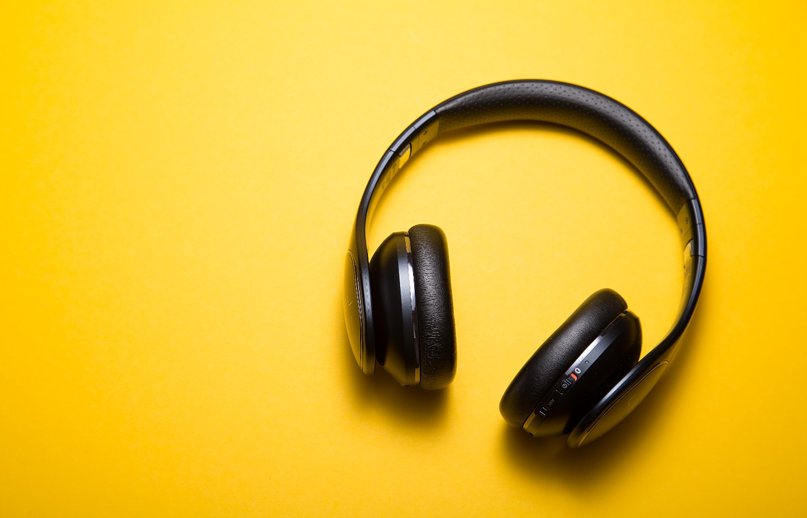[**http://24x7outsourcing.com/**](http://24x7outsourcing.com/)

**Sound Translation and Transcription Service**

**Sound Translation as a Marketing furthermore, Business Translation Tool**

"It was my first an ideal opportunity to purchase the record administration on 24x7offshoring.com. Experiencing met difficulty with the document transferring, I connected with the client care.

Everything worked out in a good way aside from the last installment on which I was informed that the group would stand by me until the constraints on my PayPal account were lifted. Recently, I sorted it out lastly paid effectively. Honestly, the record I got is worth of learning.

A debt of gratitude is in order for the polished methodology of my typographer and the tolerance of the client care."

**Linbo Li**

Sound interpretation can incorporate a lot of interpretation tasks, necessities and prerequisites. Some sound interpretation is a basic voice over interpretation for something like e-learning materials, or a book recording interpretation and recording.

Different sorts incorporate sound record interpretation; when the source language is sound recorded, and the last conveyance is a composed report interpretation, translated from the sound account.

For instance, here and there customers will demand Greek to English interpreted interpretation. For this situation, the last conveyed interpretation would be a Greek report interpretation of sound chronicle.

**Sound Translation for Voice Overs, E-learning,**

**Book recordings and the sky is the limit from there**

Sound interpretation, regardless of whether sound record interpretation, voice over interpretation, or other sound interpretation materials, are significant for e-learning organizations, language learning programming and online language e-learning destinations, book recordings, programming with sound guidelines, and numerous other business and administration apparatuses.

At whatever point conceivable, kindly give a composed duplicate to go with the source language for our reference. This will assist us with offering the least interpretation cost conceivable.

**A couple of instances of sound interpretations in some basic dialects are:**

Voice over interpretation from English to Spanish for programming sound guidance manuals, sound accounts for promoting and publicizing interpretation, and significantly more.

Book recording interpretation from French to English, Russian scholarly interpretation for book recordings, Spanish sound course reading interpretation, and different sorts of books.

The video can be deciphered either from its record, or straightforwardly from the video document. The interpretation will take the words expressed in the first video and convert them into the necessary language.

Sound to sound interpretation - this is perhaps the most basic types of sound interpretations; requiring a straightforward spoken interpretation of the source language to the objective language. The last sound arrangement or record type for conveyance will fluctuate from one customer to another.

Site sound interpretation for e-learning sites, instructional and instructional exercise site content, site limitation with sound interpretation, and substantially more.

As of late a customer required Arabic interpretation for sound recorded substance on his e-learning site.

While we underline that we can give any sort of expert record interpretation administration, we can likewise give sound language interpretation in almost any language, or under any circumstance.

With an organization of more than 5,000 interpretations with industry-explicit interpretation experience, we keep on being a worldwide driving interpretation organization.

**AUDIO TRANSLATION**

**https://24x7offshoring.com/**

**http://24x7outsourcing.com/**